|  |  |
| --- | --- |
| best anime to watch  In 2023 | Here are some of the best anime to watch. |

There are numerous animations produced and released all over the world every year. Here, anime, which is a Japanese term originating in Japan especially means the animations made in Japan.

It is said that the first Japanese animation was made and released in 1917. Speaking of the earliest famous anime in Japan, Astro Boy (a.k.a. Mighty Atom) was released in 1963 as the first series aired on TV. Hundreds of new anime are aired on TV and distributed to movie streaming platforms and come to the screens every year, and the number of must-watch titles is increasing year by year.

The industry of anime has prospered substantially in Japan partly because the country has other Japanese pop cultures such as manga, video games, and light novels. Some popular anime are adaptations of manga, video games, light novels, and other media. And, anime has flourished worldwide so rapidly since anyone can access Japanese animations with English dubs and subtitles.

Here are 30 best anime series of all time including both the classic anime franchises and the brand new shows. This greatest anime list will help beginners to find which anime to start watching within the world or anime fans to decide the next one to try. Otherwise, check the best anime by Freak’s standards.

|  |  |  |
| --- | --- | --- |
| **Anime Name** | **IMDB’s Ratings** | **Creator Name** |
| One Piece | 8.9/10 | Eiichiro Oda. |
| Naruto | 8.4/10 | Masashi Kishimoto |
| Bleach | 8.2/10 | Noriaki Kubo |
| Baki Son of Oger | 6.8/10 | Keisuke Itagak |
| Hajime no Ippo | 8.8/10 | George Morikawa. |

**Anime**

A show that one viewer sees as being ultraviolent for the sake of it is a masterclass in realism to another. Slice-of-life shows don't appeal to everyone, but to some, there's nothing more comforting. Huge robots doing battle is a bore to many, while others buzz off the idea. From shonen, seinen, and shoujo to mecha, harem, and the ever-popular isekai, there really is something for everyone in the world of anime. However, there's a handful of special shows that transcend the trappings of their genres, and it's those universal crowdpleasers we're going to look at today. From seminal shows that inspired generations of fans and creators to the modern-day classics that stand as a shining example of the medium, we're ranking the 50 best anime series of all time.

In 1711, a group of alchemists making the journey across the Atlantic are granted immortality after successfully summoning a demon, though only one of them is let in on the secret of how to make the eternal life-giving elixir. They go their separate ways and settle in different locations around the world. Later, in Prohibition-era New York, one of the alchemists is on the verge of recreating the elixir when it is stolen. It ends up changing hands numerous times, mistaken for a potent alcohol. It's a story about experimental science and mafia families tied together by two happy-go-lucky thieves named Isaac and Miria, who accidentally become immortal. A classic shonen title that began serialization in Weekly Shonen Jump in 1998, Yoshihiro Togashi's "Hunter x Hunter" follows a boy named Gon Freecss, who goes on a fantastic adventure after he finds out that his absent father is actually a famous Hunter. In Togashi's world, Hunters are people who make a living tracking down dangerous villains, rare animals, legendary treasures, and all manner of hard-to-find things. Gon's father Ging Freecss is a Double Star Ruins Hunter, and the youngster has his work cut out for him if he's going to live up to his dad's reputation.

Nippon Animation made a "Hunter x Hunter" anime in 1999, which lasted for 62 episodes. While it's definitely worth your time (especially if you prefer a darker color palette), the general consensus is that the 2011 remake from Madhouse is superior. It's more in-depth at 148 episodes and feels a lot more fresh. It ticks all the shonen boxes, but it sets itself apart from many of its competitors in the genre in several ways. Perhaps chief among them is the power system, which is well-defined and easy to understand, unlike a lot of similar shows. There's also the fact that the antagonists are far more rounded than many shonen baddies, with clearly defined goals that are actually relatable in a lot of cases.

<https://aniwatch.to/search?keyword=Baki>

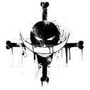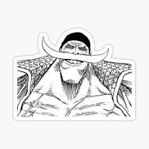 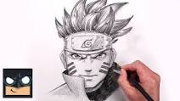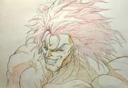

v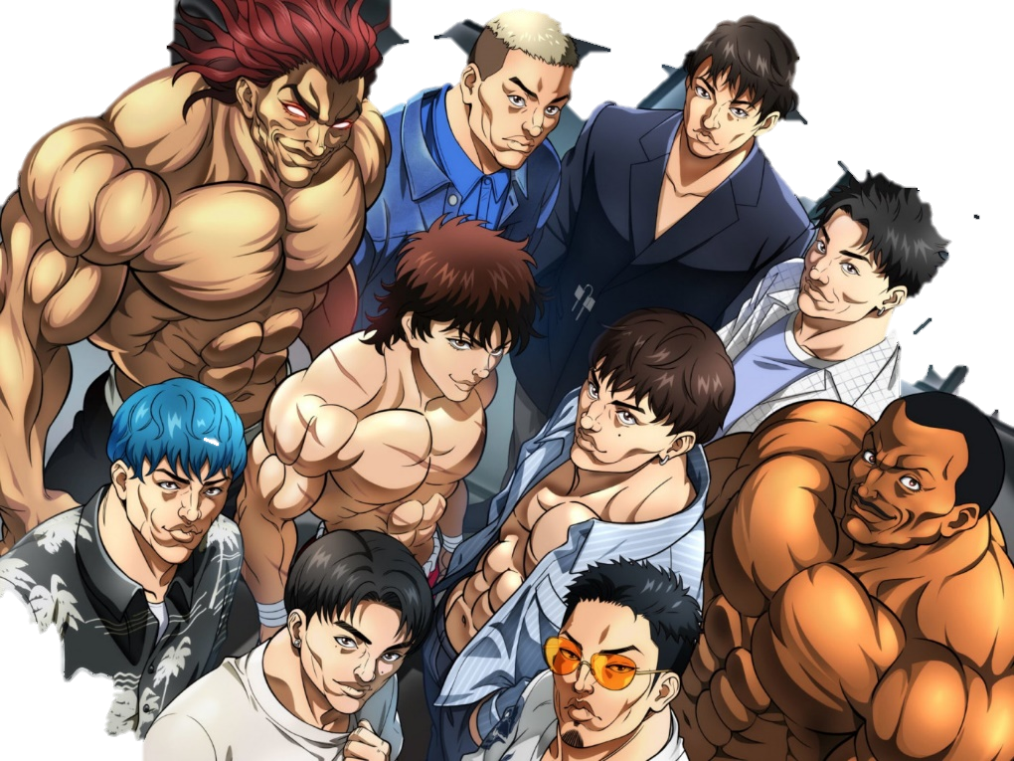

**So if you want to join this Masculine Gang go and watch recommended animes then join GYM.**

Milk Pack

Calcium

Protein

Protein

Shake

No pain No gang